Steps to install & configure OpenLdap for windows:

- Download open Ldap from http://www.userbooster.de/en/download/openldap-for-windows.aspx.

- Click on next.

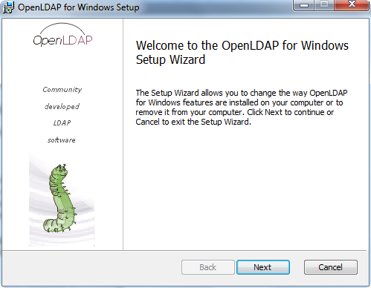

- Accept the license agreement and click next.

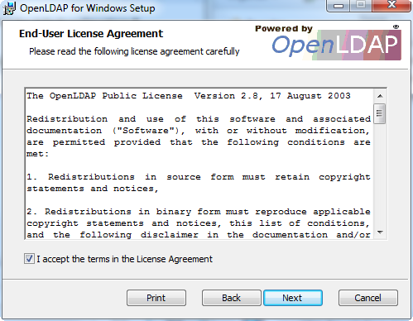

- Choose the Installation Directory and click Next.

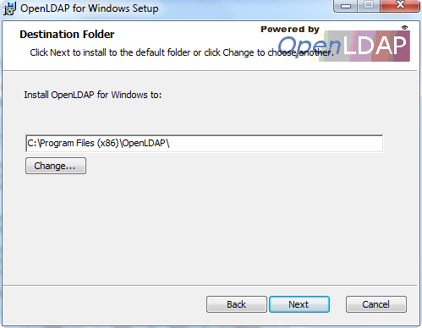

- Click Next in the below window.

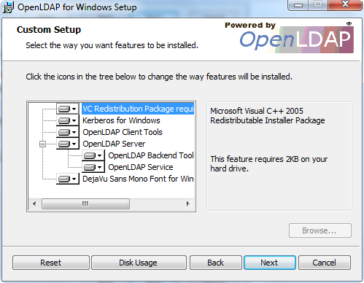

- Choose the default settings and click next.

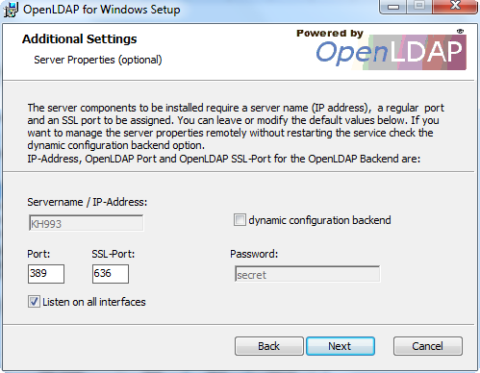

- Select the backend for ldap as SQL.

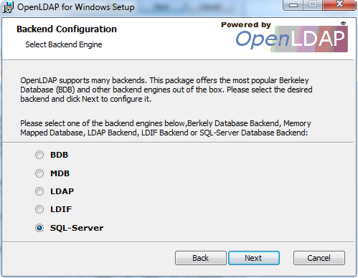

- Give the SQL instance name, user id, and password and click test connection.

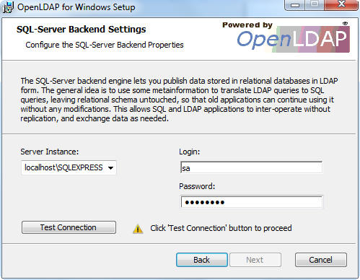

- Test connection should be successful. A green Tick appears as shown below. Click next to continue installation.

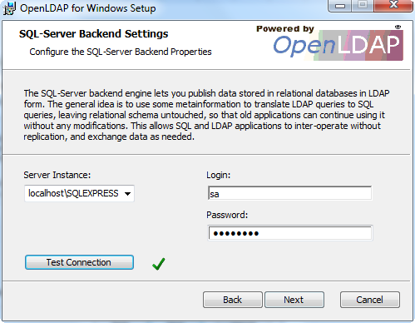

- Click on Install to start the installation.

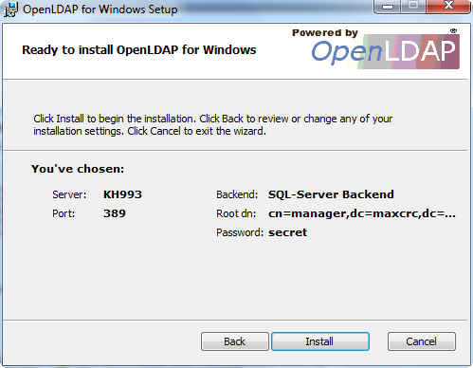

- Click on finish

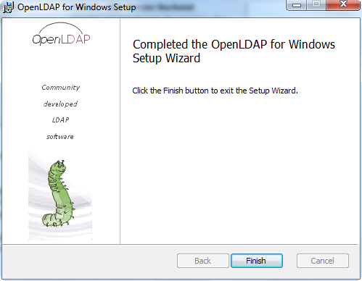

- After successful installation; open the openLdap installed folder[C:\OpenLdap], open the slapd.conf file. In this you can view the schema details and the backend server details that were donein step#3.

- To check if the slapd.conf file has been successfully edited, open the cmd prompt[in the installed directory ]and execute the command:

>slaptest -u

output: config file testing succeeded

Now run the ldap server using the command:
>slapd -d -1

o/p: Starting slapd

- Now install the JSExplorer to connect to ldap from: http://jxplorer.org/downloads/users.html

- Launch the JSExplorer and click connect, and give the details as below and click OK[o/p: If connection is successful, you can view the director structure]

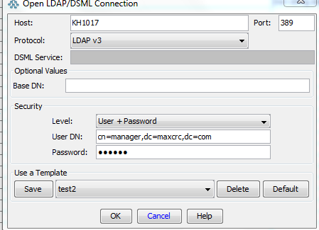

- Now in the syncconsole, create a user with UserID: manager and try to login with that user after enabling the Ldap in the syncconsole.properties file and can proceed with testing.

- You can use the attached sample syncconsole.properties & slapd.conf files.

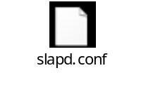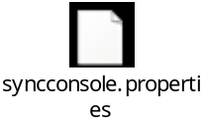

Note: The client should send the password as expected in the server[Ldap] or vice versa. If the server expects plain text, then the client should send password as plain text.

For reference , follow the link: http://www.idevelopment.info/data/LDAP/LDAP_Resources/OPENLDAP_Install_CentOS5.shtml#slapd Configuration – (slapd.conf)

